**OPERATING SYSTEM LAB (COM -312)**

**Simulating Linux Terminal File Explorer functionality using special keys, basic commands, and open files features.**

**CSE, MODEL INSTITUTE OF ENGINEERING AND TECHNOLOGY**

## BACHELOR OF ENGINEERING

**In**

## Computer Science & Engineering

**SUBMITTED BY**

**Ankush Raina (2021A1R059)**

**Aditya Zalpuri (2021A1R057)**

**Shradha Sharma (2022A1L016)**

**Kanav Sharma (2021A1T055)**

**Sparsh Sharma (2021AR056)**



**ACKNOWLEDGEMENT**

Under CRIE (Center for Research, Innovation and Entrepreneurship) we both worked under the guidance of mentors of CRIE, who guided us through a way leading to professionalism and practical hands-on work experience. It is indeed with a great pleasure and immense sense of gratitude that we acknowledge the help of these individuals. We are highly indebted to our Director Ankur Gupta, “MODEL INSTITUTE OF ENGINEERING AND TECHNOLOGY”, for the facilities provided to accomplish this main project. We would like to thank our Prof.Ashok Kumar, Head of the Department of Computer Science and Engineering, MIET. For this constructive criticism throughout our project. We feel elated in manifesting our sense of gratitude for our internal project guide. Asst. Saurabh Sharma, Department of Computer Science and Engineering, MIET.He has been a constant source of inspiration for us, and we are very deeply thankful to him.

**FACULTY AND MEMBER**

## Dr. Ankur Gupta - He is the Director at the ModeI Institute of Engineering and Technology, Jammu, India, besides being a Professor in the Department of Computer Science and Engineering. Prior to joining academia, he worked as Technical Team Lead at Hewlett Packard, developing software in the network management and e-Commerce domains. He has 2 patents to his name and 20 patents pending. He obtained his B.E, Hons. He is a senior member of the ACM, senior member IEEE and a life-member of the Computer Society of India. He has received competitive grants over Rs 2 crores from various funding agencies and faculty awards from IBM and EMC.

## Prof. Ashok Kumar - He has over 21 years of experience in industry, academics, research and academic administration. He did his Doctorate from IKG Punjab Technical University, Jalandhar; Master of Engineering from Punjab Engineering College, Chandigarh and Bachelor’s degree from NIT, Calicut, Kerala. He is Fellow of Institution of Electronics and Telecommunication Engineers (IETE). His research interest areas are Optical Networks, Electronics Product Design, Wireless Sensor Networks and Digital Signal Processing... He is reviewer of many reputed national and international journals. He has also coordinated many national and international conferences.

## Mr. Saurabh Sharma - He is working as Assistant Professor in the Department of Computer Science at Model Institute of Engineering and Technology, Jammu and has over 10 years of experience in academics and research. He has done his M. Tech CSE in Web Mining from Maharishi Markandeshwar University, Mullana, Ambala (HR) in the year 2011.His research interest areas are Web Mining, Data Mining, Machine Learning, ANN, Pattern Classification and Object Identification. He has, to his credit, 25 research papers published in journals of national and international repute and he has guided 11 M. Tech Dissertations.

**CONTENTS**

Acknowledgement 1

Faculty and member 2

Abstract 3

Introduction 4

Objective 5

Advantages and disadvantages 6

Flowchart 7

Working 8

Code 9

Implementations 10

**ABSTRACT**

**______________________________________________________**

The visualization of hierarchies is very important for digital information management and presentation systems. Especially in the context of Personal Information Management, file explorers play a very important role. Currently the most common file explorer visualizations are Windows Explorer and the simple zoomable visualization offered by Microsoft Windows. This work explores the issue of file explorer visualization through a user study based on interviews and an experiment.

It provides a graphical user interface for accessing the file systems. It is also the component of the operating system that presents many users interface items on the screen such as the taskbar and deskto

1. **Introduction**

File Explorer is a file browser which enables us to organise our files or folders in the way we would like it to be organised. It has various functions and as today’s technology goes on getting better and better many more functions are being included.

Some of its main functions are as follows:

* 1. File Management.
  2. Create or delete a file.
  3. Move or copy a file.

In 1995, Microsoft first released test versions of a shell refresh, named the Shell Technology Preview, and often referred to informally as "New Shell”. The update was designed to replace the Windows 3.x Program Manager/File Manager based shell with Windows Explorer. The release provided capabilities quite similar to that of the Windows "Chicago" (codename for Windows 95)shell during its late beta phases, however, was intended to be nothing more than a test release

1. **Objective**

**A. Normal Mode**

1. Files should be displayed alphabetically using explorer.
2. Scrolling: 1 file scrolled at a time.
3. Opening files should be done in their default apps.
4. Back and forward implemented the same as we observe in the Linux GUI file explorer app.
5. Assumed: application home should be given while running the program.

**B. Command Mode**

1. If changes are made in the current dir (shown currently on terminal), the changes would be updated (on terminal) when the user comes out of the command mode by pressing Special Key.
2. Goto would update the terminal with a new path immediately.
3. All paths would be relative to Application home.

Our aim is to develop a program that displays the file system on the terminal and helps users navigate through it using special keys, open files and execute basic file commands. We must simulate the basic functionality of a Linux terminal using a shell script

1. **Advantages of File Explorer**

**3.1** It centralises important Documents in one place:

Documents are often siloed across desktop computers, laptops, tablets, mobile phones, flash drives, and email inboxes. File explorer systems can bring an organisation’s documents together in one place for easy accessibility. Instead of spending precious time trying to find that one document buried in an archived email thread, you can find what you need and get back to work.

**3.2** It reduces Work:

A staggering 83% of employees must recreate pre-existing documents because they can’t locate them on their corporate network. While some documents may take just a few minutes to prepare, many require numerous man-hours to complete. Even if the rework time is low per document, that time can quickly add up across documents and employees. File explorer systems help keep documents organised, so your workforce can quickly find what they need and avoid reinventing the wheel.

**3.3** It cuts down on emails:

Embracing file explorer has cut down on our email volume, which has improved efficiency and helped us avoid frustrations.

**4. Disadvantages of File Explorer**

**4.1** Data Redundancy:

Often, within an organization, files and applications are created by different programmers from various departments over extended periods of time. This can lead to data redundancy*,*a situation that occurs in a database when a field needs to be updated in more than one table.

**4.2** Inconsistency:

Because of data redundancy this often leads to data inconsistency. Which means that the same copies of data located in various places contain different values. For preventing this, there should be paper listing among different files.

**4.3** Accessibility:

Accessing data in file explorer system is not an effortless process. It is not convenient as it should be. Whenever a user needs to access an information using different approaches, they must execute a special program

**5. Flowcharts**

**Fig.A**

**6. WORKING**

* **The File Explorer displays:**

1. **File/Folder**

* **Provides Functions Like:**

1. **Delete**
2. **Display**
3. **Edit The File**
4. **Move To the Directory**
5. **Scroll Up and Do**

**7. CODE**

**NORMAL MODE**

Fig 1:

Fig 2:

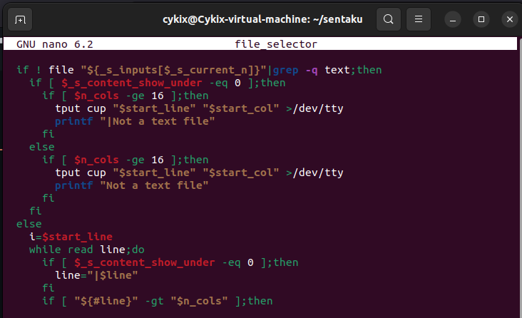

Fig 3:

Fig 4:

Fig 5:

Fig 6:

Fig 7:

**COMMAND MODE**

Fig 9:

Fig 10:

Fig 11:

Fig 12:

**8. IMPLEMENTATION**

**Normal Mode(View only)**

**Fig. 1:**

**COMMAND MODE (EDITING MODE*)***

**Fig. 2:**

**7. References**

**6.1** <https://www.hitechwhizz.com/2021/02/7-advantages-and-disadvantages-limitations-benefits-of-file-management-system.htm>[l](https://www.hitechwhizz.com/2021/02/7-advantages-and-disadvantages-limitations-benefits-of-file-management-system.html)

**6.2** <https://en.wikipedia.org/wiki/File_Explorer>

**6.3** https://github.com/rcmdnk